PO error – Function project accounting distribution transaction currency sales AMT has been incorrectly called

<https://itsdterracat.zendesk.com/agent/tickets/302443>

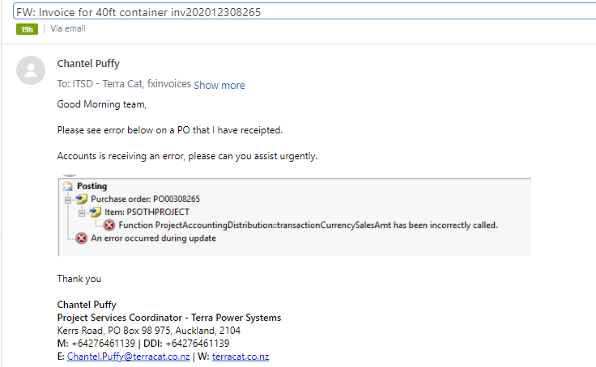

When someone goes to post the vendor invoice the above error pops up

These are the steps to take

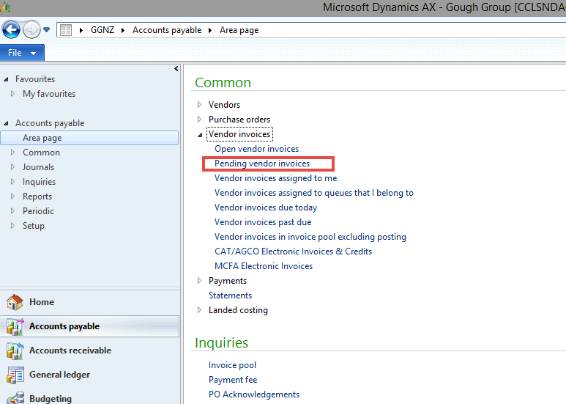

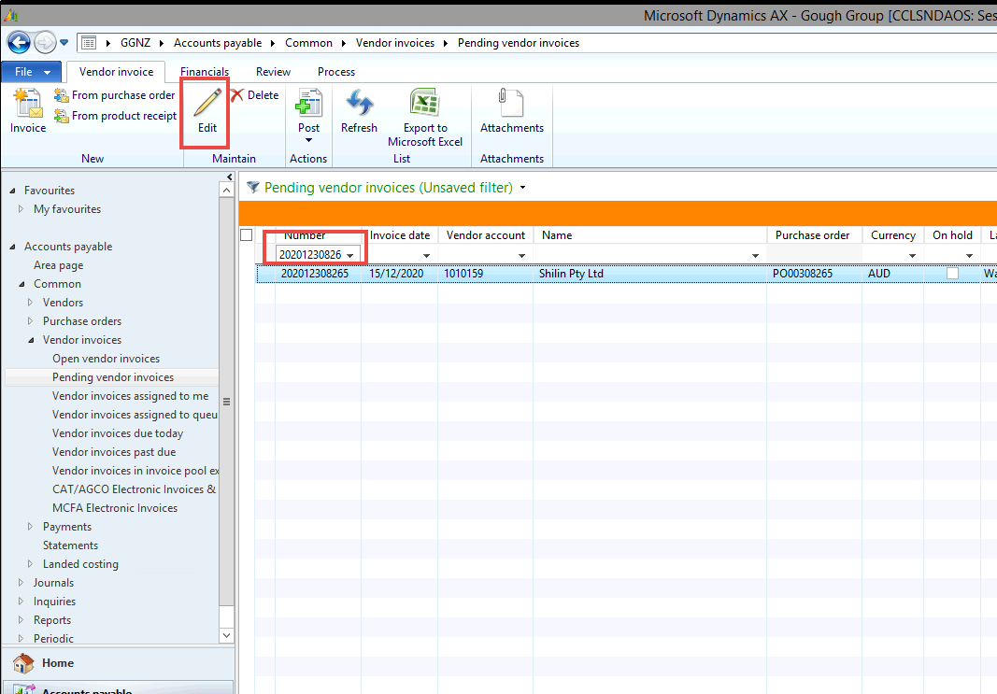

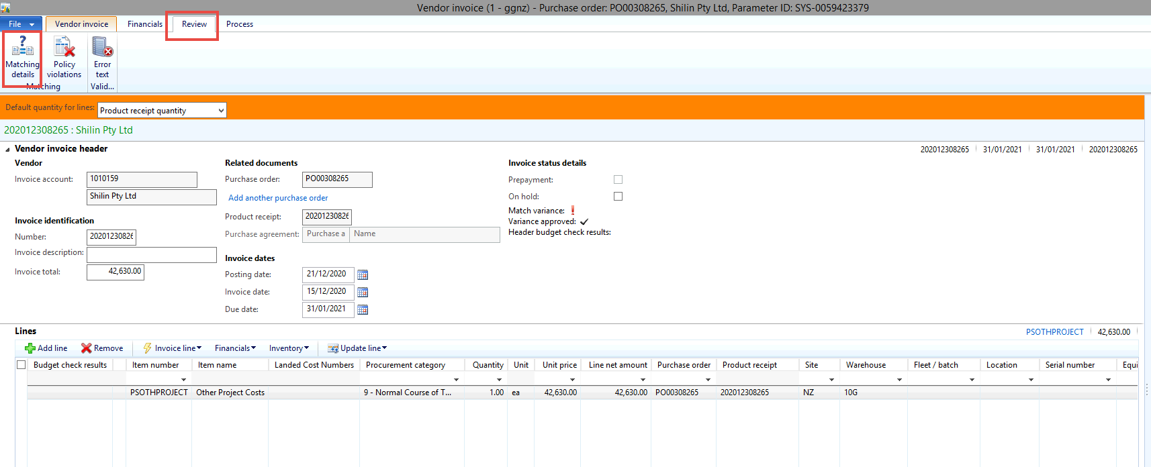

Tick the approve box

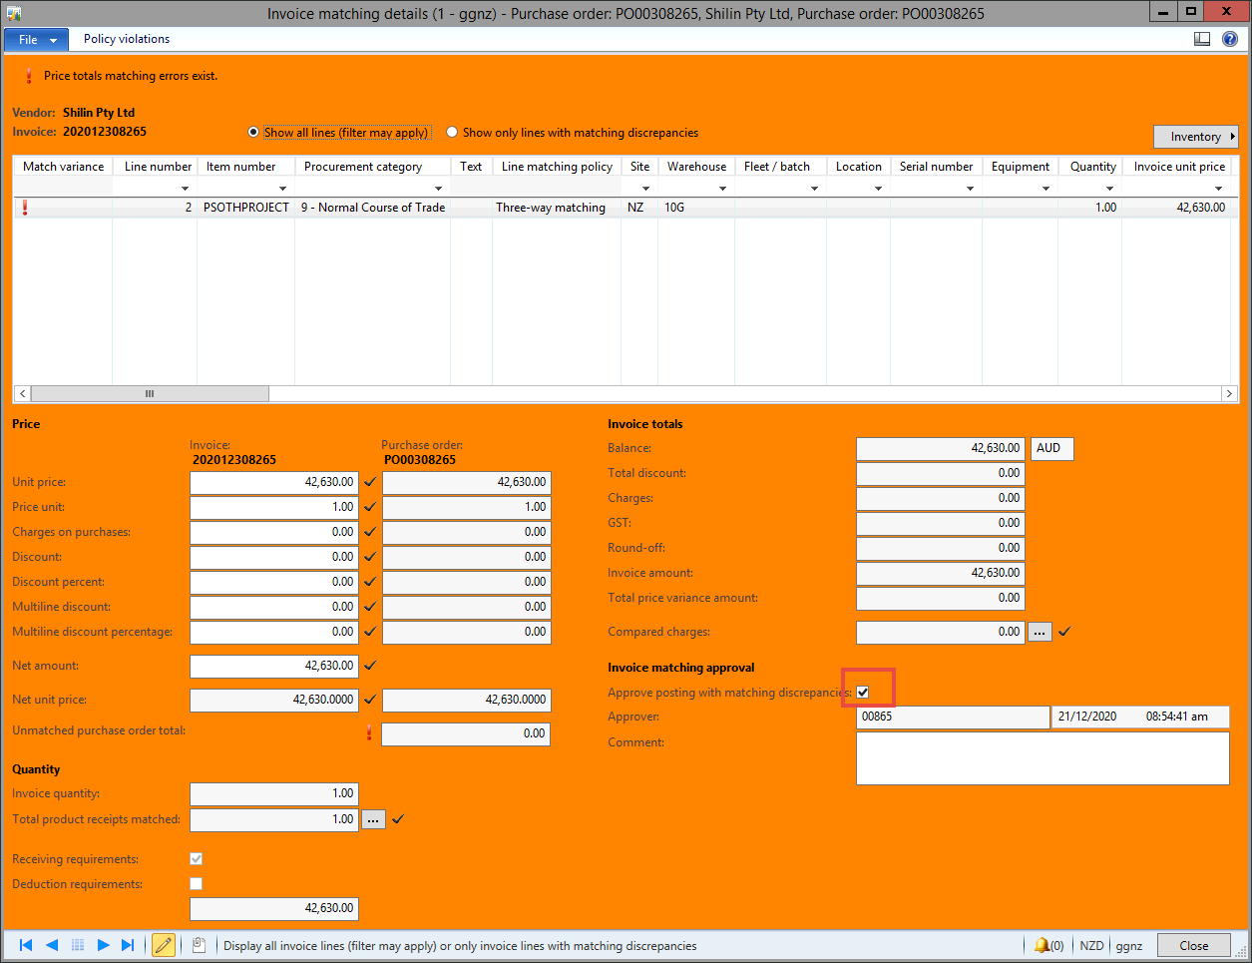

Post invoice

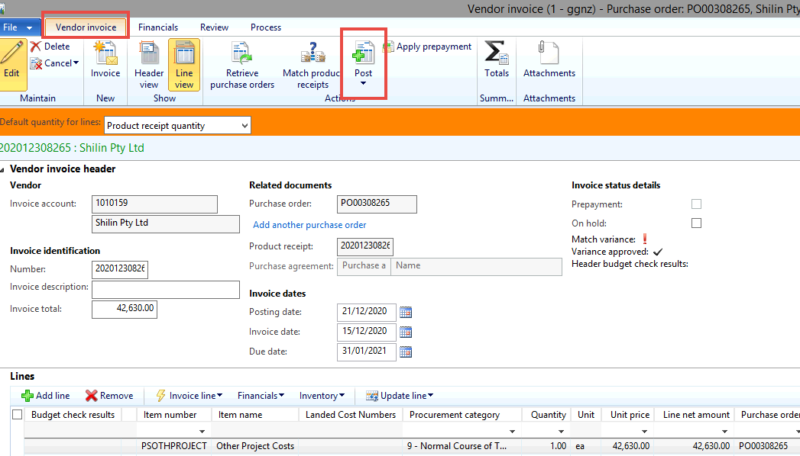

**Resolution:**

Couldn’t cancel the PO as there was an invoice on it.

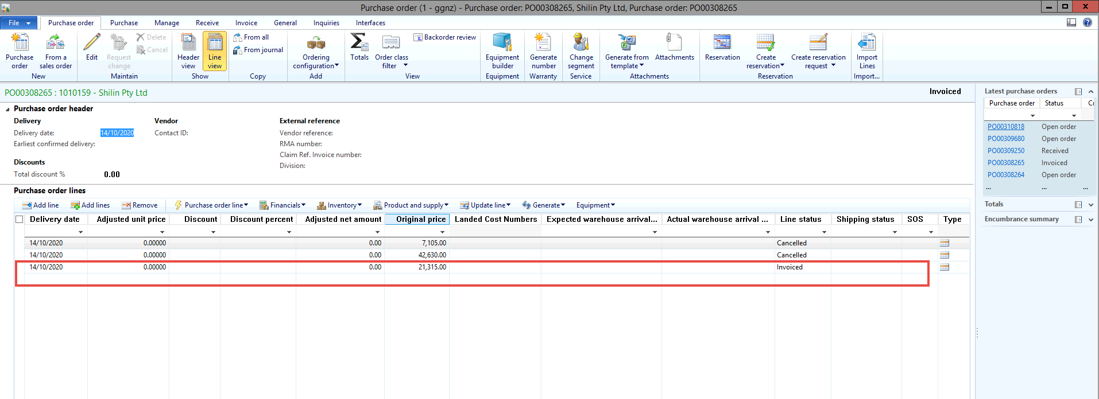

Went to product receipt – cancel product receipt

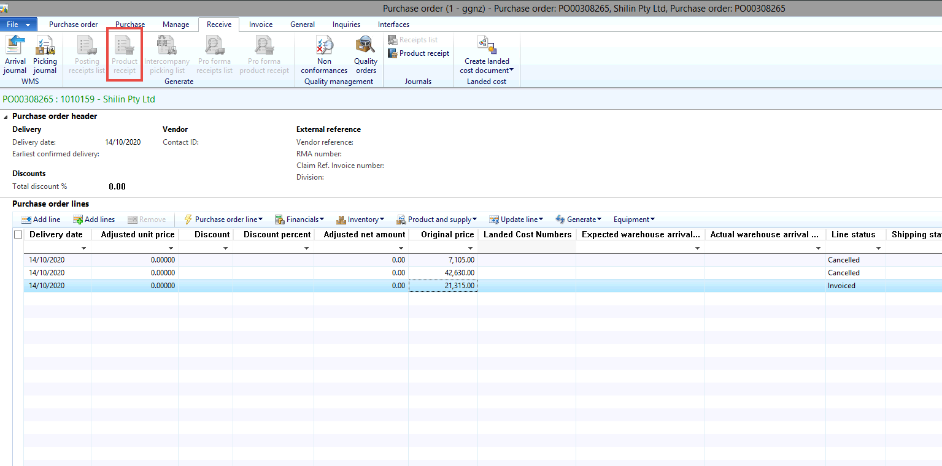

Cancelled the 2 un-invoiced lines

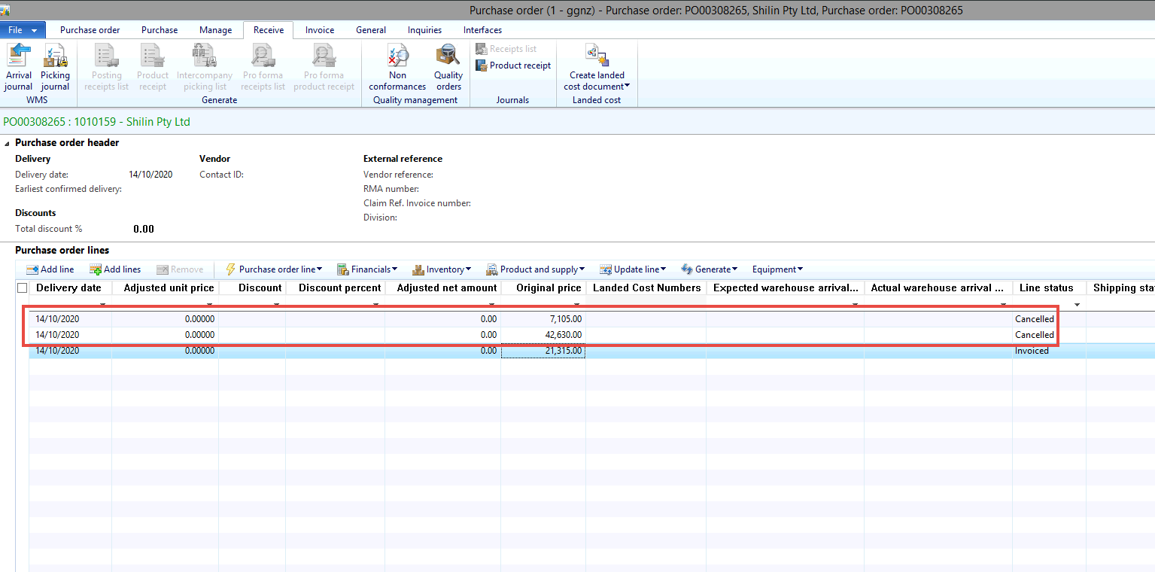

To cancel the lines – select the line you want to cancel (do this for each line you want to cancel)

Click on **update line > deliver remainder**

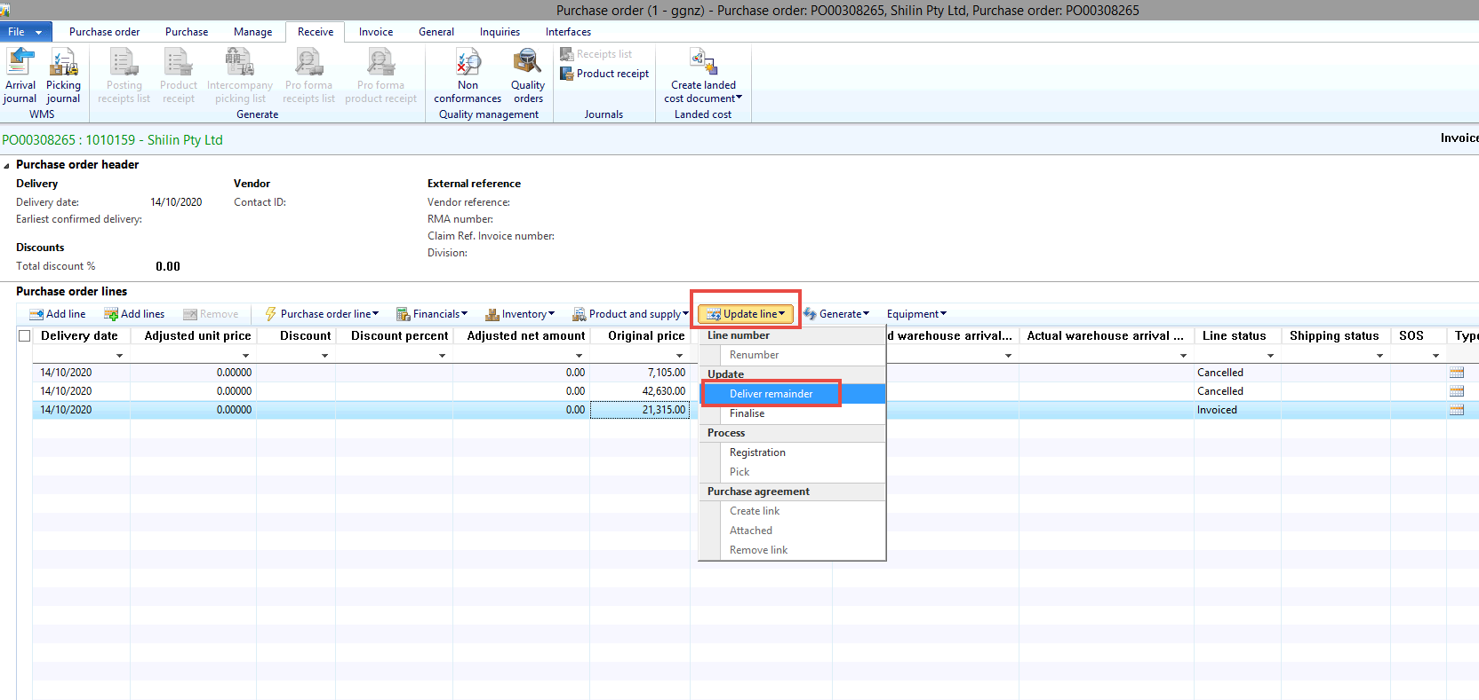

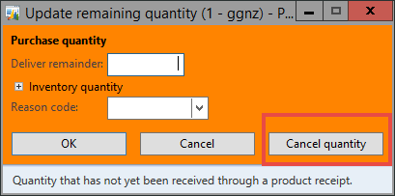

Created new PO for those 2 same lines